**Mid-Level Design :**

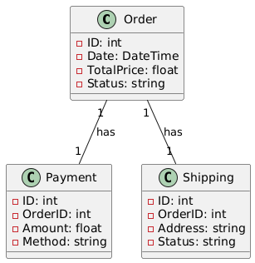

**Low-Level Design :**

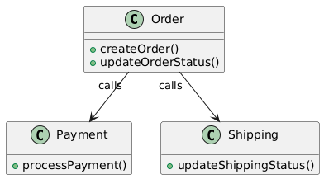

**Mapping Between Models:**

* **Description:**
  + **The mid-level design shows the modules (Order, Payment, Shipping) and their relationships.**
  + **The low-level design adds detailed methods and operations to each class**.
  + **Mapping Example:**
    - **Order Module:**
      * Maps to the Order class in the low-level design.
      * Methods: createOrder(), updateOrderStatus().
    - **Payment Module:**
      * Maps to the Payment class in the low-level design.
      * Methods: processPayment().
    - **Shipping Module:**
      * Maps to the Shipping class in the low-level design.
      * Methods: updateShippingStatus().

**Detailed Design Rationale:**

* **Purpose:** Justify key design decisions for each module.
* **Examples:**
  + The Order class includes the updateOrderStatus() method to ensure centralized handling of order updates, maintaining consistency.
  + The processPayment() method is isolated in the Payment class to allow flexibility in adding new payment methods in the future.
  + The relationship between Order and Shipping ensures that shipping updates can be linked to the corresponding order seamlessly.
* **Rationale:**
  + These design decisions enhance modularity, maintainability, and scalability while keeping the system flexible for future changes.